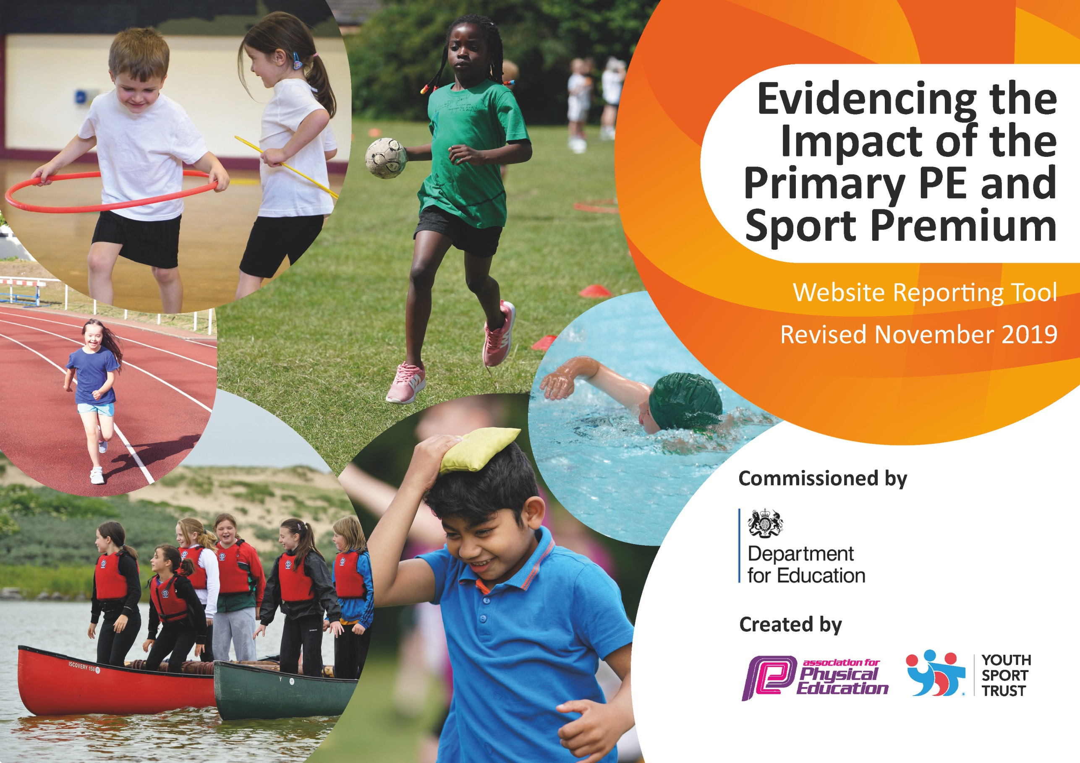
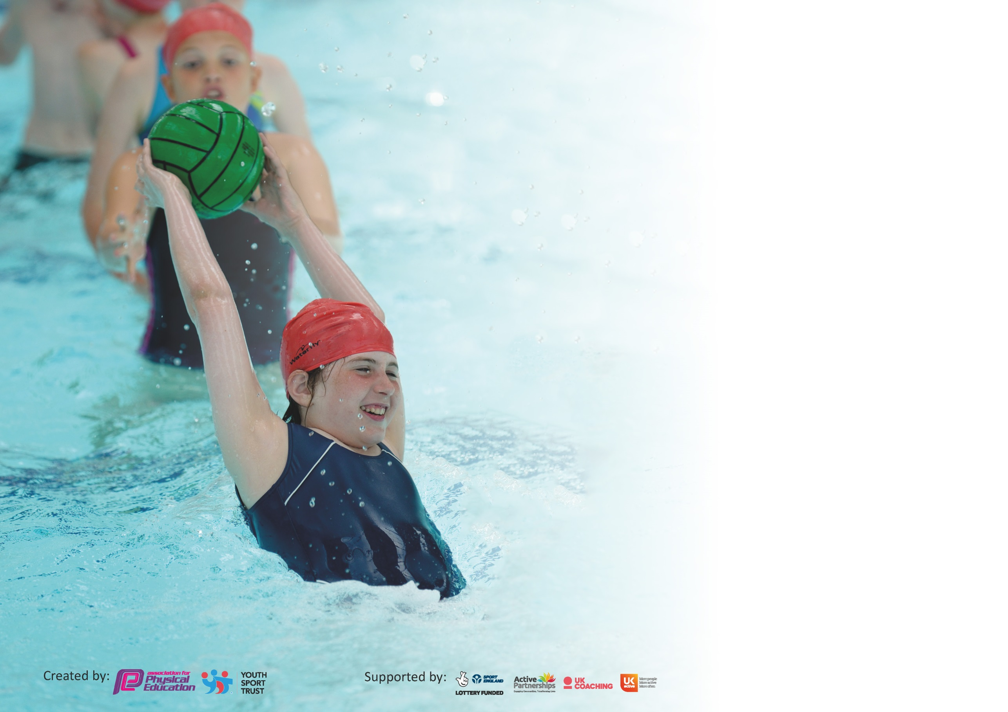

It is important that your grant is used effectively and based on school need. The Education Inspection Framework (Ofsted 2019 p64) makes clear there will be a focus on ‘whether leaders and those responsible for governors all understand their respective roles and perform these in a way that enhances the effectiveness of the school’.

Under the Quality of Education criteria (p41) inspectors consider the extent to which schools can articulate their curriculum (INTENT), construct their curriculum (IMPLEMENTATION) and demonstrate the outcomes which result (IMPACT).

To assist schools with common transferable language this template has been developed to utilise the same three headings which should make your plans easily transferable between working documents.

Schools must use the funding to make additional and sustainable improvements to the quality of Physical Education, School Sport and Physical Activity (PESSPA) they offer. This means that you should
use the Primary PE and Sport Premium to:

- Develop or add to the PESSPA activities that your school already offer
- Build capacity and capability within the school to ensure that improvements made now will benefit pupils joining the school in future years

Please visit gov.uk for the revised DfE guidance including the 5 key indicators across which schools should demonstrate an improvement. This document will help you to review your provision and to report your spend. DfE encourages schools to use this template as an effective way of meeting the reporting requirements of the Primary PE and Sport Premium.

We recommend you start by reflecting on the impact of current provision and reviewing the previous spend.

Schools are required to publish details of how they spend this funding as well as on the impact it has on pupils’ PE and sport participation and attainment by the end of the summer term or by 31st July 2021 at the latest.

We recommend regularly updating the table and publishing it on your website throughout the year. This evidences your ongoing self-evaluation of how you are using the funding to secure maximum, sustainable impact. Final copy must be posted on your website by the end of the academic year and no later than the 31st July 2020. To see an example of how to complete the table please click HERE.

Support for review and reflection - considering the 5 key indicators from DfE, what development needs are a priority for your setting and your pupils now and why? Use the space below to reflect on previous spend and key achievements and areas for development.

Key achievements to date until July 2021: | Areas for further improvement and baseline evidence of need:
Engagement of all pupils in regular physical activity:  • Ensured that greater than 75% of children are able to swim at the end of year 6  • Increased numbers of pupils competing in games/competition at lunch times.  • Increased the number of days the daily Mile is completed across the school (every day Monday-Friday).  Broader experience of a range of sports and activities offered to all pupils:  • Introduced a wider range of sports to classes and at play times.  • Introduced a wider range of sports into the school sports day. | - To target more in school and inter school competitions, post-covid restrictions.  - To further raise attainment in primary school swimming to pass last year’s total of 80% of Year 6 children able to swim 25m.  - To raise the profile of PE, sport, healthy lifestyles and wellbeing across the school. To do this by delivering targeted PE and wellbeing lessons with an assigned specialist member of staff within school.

Meeting national curriculum requirements for swimming and water safety.
What percentage of your current Year 6 cohort swim competently, confidently and proficiently over a distance of at least 25 metres?  N.B. Even though your pupils may swim in another year please report on their attainment on leaving  primary school at the end of the summer term 2021. | 80%
What percentage of your current Year 6 cohort use a range of strokes effectively [for example, front crawl, backstroke and breaststroke]? | 70%
What percentage of your current Year 6 cohort perform safe self-rescue in different water-based situations? | 80%
Schools can choose to use the Primary PE and Sport Premium to provide additional provision for swimming but this must be for activity over and above the national curriculum requirements. Have you used it in this way? | Yes – additional swimming time was allocated for Y6 children in the Summer term

Action Plan and Budget Tracking
Capture your intended annual spend against the 5 key indicators. Clarify the success criteria and evidence of impact that you intend to measure to evaluate for pupils today and for the future.

Academic Year: 2020/21 | Total fund allocated: £16910 | Date Updated: 31st July 2021
Key indicator 1: The engagement of all pupils in regular physical activity – Chief Medical Officer guidelines recommend that primary school pupils undertake at least 30 minutes of physical activity a day in school |  |  |  | Percentage of total allocation:
 |  |  |  | 24%
Intent | Implementation |  | Impact
Your school focus should be clear what you want the pupils to know and be able to do and about  what they need to learn and to  consolidate through practice: | Make sure your actions to achieve are linked to your intentions: | Funding allocated: | Evidence of impact: what do pupils now know and what can they now do? What has changed?: | Sustainability and suggested next steps:
To resource PE within the school Purchase of new equipment stock. Enhancing stock where needed. To increase the incidences of the Whole school daily mile.  To improve the quality of break-time / lunchtime experience of pupils – training of Junior Play Leaders & Mid-Day Assistants, and purchase of additional playground equipment that empowers children in their active play experiences | Purchase of additional P.E. stock for lunchtime activities.  Increased opportunities to do the daily mile.  Training for Junior Play Leaders & Mid-Day Assistants as required; purchase of additional small play equipment & storage; continual monitoring / additional training / purchase of top-up equipment.  Sports coaches leading lunch-time table-tennis/archery club and playground clubs | £4000 | Resources purchased add to a higher quality lesson and physical experience.  Age and stage appropriate equipment has increased pupil engagement during lunchtimes and out of school time  Whole school scheme updated in line with New curriculum. | The broader range of sporting equipment is encouraging those children not usually involved in sport to take an interest and increase their levels of physical activity.  To continue to develop the impact of play leaders to increase participation in physical activity of KS1 and lower KS2 pupils.  Extend the use of equipment to after school clubs and develop the extra-curricular programme.
Key indicator 2: The profile of PESSPA being raised across the school as a tool for whole school improvement |  |  |  | Percentage of total allocation:
 |  |  |  | 35%
Intent | Implementation |  | Impact
Your school focus should be clear what you want the pupils to know and be able to do and about  what they need to learn and to  consolidate through practice: | Make sure your actions to achieve are linked to your intentions: | Funding allocated: | Evidence of impact: what do pupils now know and what can they now do? What has changed?: | Sustainability and suggested next steps:
Raising the profile and quality of P.E. / sport by hiring specialist P.E. practitioners to work alongside staff when teaching P.E.  To develop the pupils appreciation of sport and PE and to raise attainment in the subject.  To link developments in PE to wellbeing and to raise the profile and importance of a healthy lifestyle. | Raising the profile and quality of P.E. / sport by hiring specialist P.E. practitioners to work alongside staff when teaching P.E.  Specialist staff member to teach all classes each week; Active PE and Sport and wellbeing activities linked to reading and awareness.  CPD for staff based on curriculum and wellbeing awareness. | £6000 | Regular developments in this area to begin in Autumn 2021 term. Covid guidelines have restricted significant improvement in this area.  Staff member ready to begin targeted teaching in KS1 and KS2 classes in September. | New approach in timetable will continue to develop the pupils understanding of a healthy lifestyle and PE and sport.

Key indicator 3: Increased confidence, knowledge and skills of all staff in teaching PE and sport |  |  |  |  |  |  | Percentage of total allocation:
 |  |  |  |  |  |  | 6%
Intent | Implementation |  |  | Impact
Your school focus should be clear | Make sure your actions to |  | Funding | Evidence of impact: what do |  |  | Sustainability and suggested
what you want the pupils to know | achieve are linked to your |  | allocated: | pupils now know and what |  |  | next steps:
and be able to do and about | intentions: |  |  | can they now do? What has
what they need to learn and to |  |  |  | changed?:
consolidate through practice:
Raising teaching competencies and leadership in P.E. / sport via high quality professional development for teachers, Classroom Assistants and Mid-Day Assistants. | Attendance at CPD events to develop increased expertise in the area of P.E. Training for Midday assistants.  PE lead to administer CPD to staff on approach to lessons and developments to increase physical activity in pupils. |  | £1000 | Further developments in this area to begin in Autumn 2021 term. Covid guidelines have restricted significant improvement in this area.  Lesson observations and learning walks and increase in the quality of teaching, learning and assessment. Teacher assessment showing an increase in pupil’s physical activity levels. |  |  | Moderation of teacher and specialist teacher assessment scores required to ensure consistency.  Staff and pupil questionnaires  Development of lunchtime activities.  Bespoke CPD for staff
Key indicator 4: Broader experience of a range of sports and activities offered to all pupils |  |  |  |  |  |  | Percentage of total allocation:
 |  |  |  |  |  |  | 21%
Intent | Implementation |  |  | Impact
Your school focus should be clear | Make sure your actions to |  | Funding | Evidence of impact: what do |  |  | Sustainability and suggested
what you want the pupils to know | achieve are linked to your |  | allocated: | pupils now know and what |  |  | next steps:
and be able to do and about | intentions: |  |  | can they now do? What has
what they need to learn and to |  |  |  | changed?:
consolidate through practice:
Additional achievements: Increasing the range of opportunity available in PE / sport by hiring specialist PE practitioners to work alongside staff when teaching P.E.  Support for transport and funding for overnight camping and outdoor adventure day at school in June. | Equipment purchased to broaden the range of sports provided by school; Football club , netball club, indoor games, net games, multi sports club for Reception and KS1 and KS2 Multi skills |  | £3500 | Children experienced a broader range of sporting opportunity that has visibly increased their physical activity and levels of enjoyment.  There have been restrictions to the quantity of opportunities due to covid guideline. Children demonstrated improving levels of motivation, effort and enjoyment. |  |  | Termly pupil and staff questionnaires to determine the impact each sport has had on the pupils.  Increase the number and range of clubs taking place after school and at lunch times.  Identify and target clubs going forward.
Key indicator 5: Increased participation in competitive sport |  |  |  |  |  | Percentage of total allocation:
 |  |  |  |  |  | 15%
Intent |  | Implementation |  |  | Impact
Your school focus should be clear |  | Make sure your actions to | Funding |  | Evidence of impact: what do | Sustainability and suggested
what you want the pupils to know |  | achieve are linked to your | allocated: |  | pupils now know and what | next steps:
and be able to do and about |  | intentions: |  |  | can they now do? What has
what they need to learn and to |  |  |  |  | changed?:
consolidate through practice:
To increase the number of pupils regularly attending enrichment activity – for example WPSSA interschool competitions and School Games. Increased opportunity will improve pupils motivation and social interaction. |  | Membership fees, affiliation and entry fees to a range of competitions and events. Increasing opportunity via attendance at inter-school competition. Bus hire for attending. Supply cover to free travelling staff. | £2477 |  | Inter and intra competition opportunities were limited to covid restrictions, with Halton Games suspending active competitions and events.  Competition has continued within class bubbles and will continue in this way until Autumn term 2021 when inter and intra competitions will recommence. | Develop opportunities for Intra school competition in both KS1 and KS2 and to celebrate these via media platforms and reward within school.  Use and monitor registers for clubs and competitions to gain data for the year and use this moving forward.

Signed off by
Head Teacher: | Lorraine Connolly
Date: | 31st July 2021
Subject Leader: | Paul Foster
Date: | 31st July 2021
Governor: | Kathy Keig
Date: | 31st July 2021

