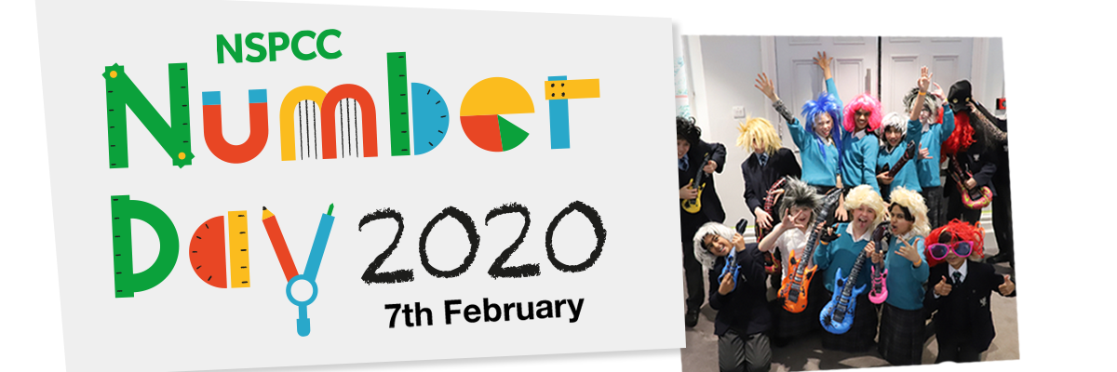

Date: 24th January 2020
Dear parents and carers,
We are excited to announce that we will be participating in the NSPCC Number Day on Friday 7th February 2020, when children will take part in fun maths activities throughout the day!
You are welcome to join your child’s class for a 30 min Maths session (or for 10-15 min, if you have more than one child) from 2.30 pm to 3 pm, and collect your child at the end.
Teachers will show you what children are working on, immerse you in fun problem-solving activities and answer any questions you may have about Maths homework, resources etc.
It’s a charitable event so we are fundraising by allowing children to either dress like their Times Table Rock Star avatar; wear something with a number on or just wear their own cloths for a donation of £1 to the NSPCC.
Making Maths Meaningful
All the money we donate to the NSPCC will help to fund their vital services such as Childline and the NSPCC Speak out Stay safe Programme, making an enormous difference to children today and to the lives of children tomorrow.
Please note that it’s entirely optional for your child to dress like an avatar and it’s optional for you to make a donation. Please speak to your child’s class teacher if you have any queries about Number Day.
Because of Number Day, the Friday’s Celebration Assembly that week will be on Thursday, 6th February from 2.30 pm.
Thank you for your support.
Best wishes,
Mrs Crabbe
Maths Lead

More information:
nspcc.org.uk/numberday | nspcc.org.uk/onlinesafety | ttrockstars.com | numbots.com

