Thursday, 30 July 2026

Dear Parents and Carers

As a school we take online safety serious and children are constantly taught in their lessons about the importance of online safety. We are aware of some media coverage over the past few days that may concern parents and children regarding online safety.

Please can I encourage you to have open and general conversations with your children about the kind of content they could encounter online, and to ensure children know where to go and who to turn to if they do come across something unsettling.

May I also remind you of the age restrictions for different social messaging platforms as all primary school age children are underage.

Please be extra vigilant when your children are using the internet and ensure that parental controls are in place. Our school website provides additional support on using the internet safely. If you have any concerns please come in and speak to Mrs Connolly or myself.

The Parentzone have issued this guidance about it - https://parentzone.org.uk/article/three-minute-briefing-momo-challenge

Many thanks,
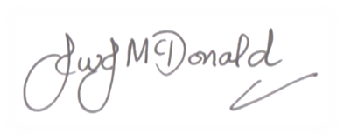
Mr J McDonald
Headteacher

