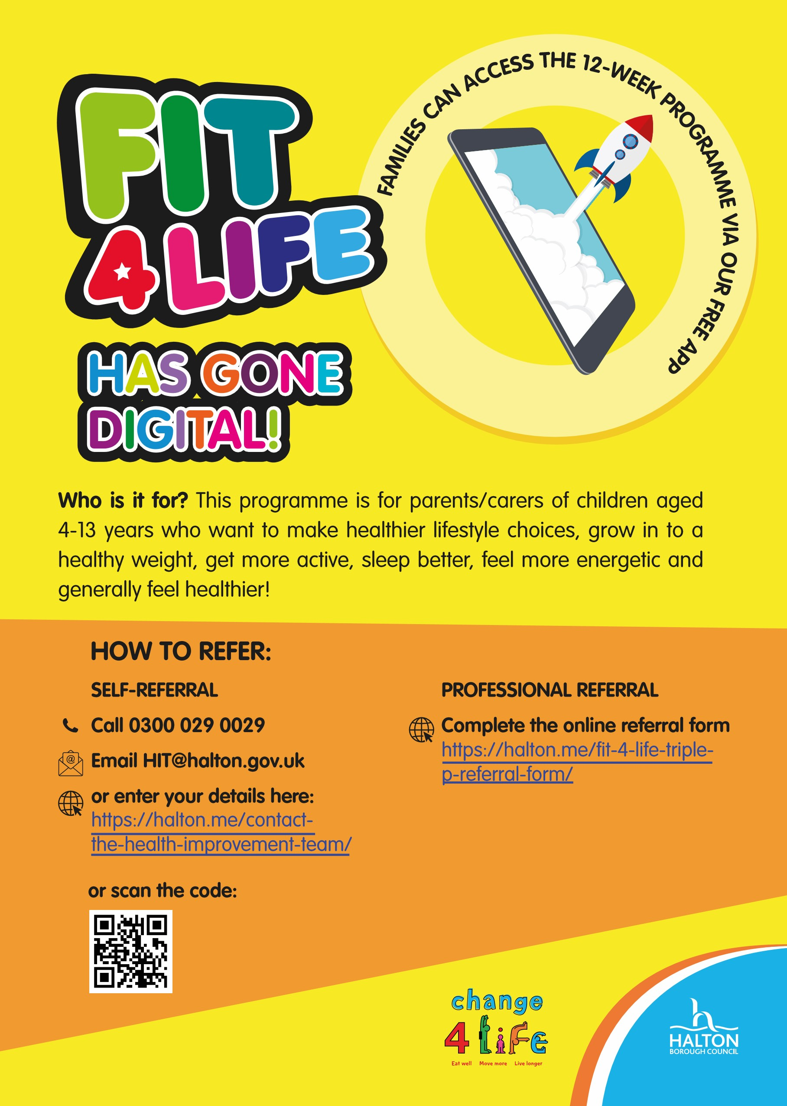
Getting started is easy:
Get in touch to book your sign-up with your coach
Download the free app
Use your access code to view your programme
Receive regular content, videos and tasks
Check in weekly with your coach via the app
12-week review, and discuss next steps
Continue for a further 12 weeks, if required
FAQs
What do I need to access the app?
You need to have access to a smartphone or tablet, and access to the internet. It is recommended to access the app via WiFi, however, the app does not use large amounts of data.
Can children and young people download the app?
The app is aimed at parents and carers of children aged 4-13 years. The content is appropriate for children to view, but the Fit 4 Life coaches will be communicating with parents/carers through the app. Therefore the parent needs to have the app on their own device and log in with their own email address.
What if I don’t have access to a smart phone or tablet?
If you cannot access content via a device, then contact the Fit 4 Life team on 0300 029 0029 team to look at alternative ways to access the programme content.
What support will I get while I’m on the programme?
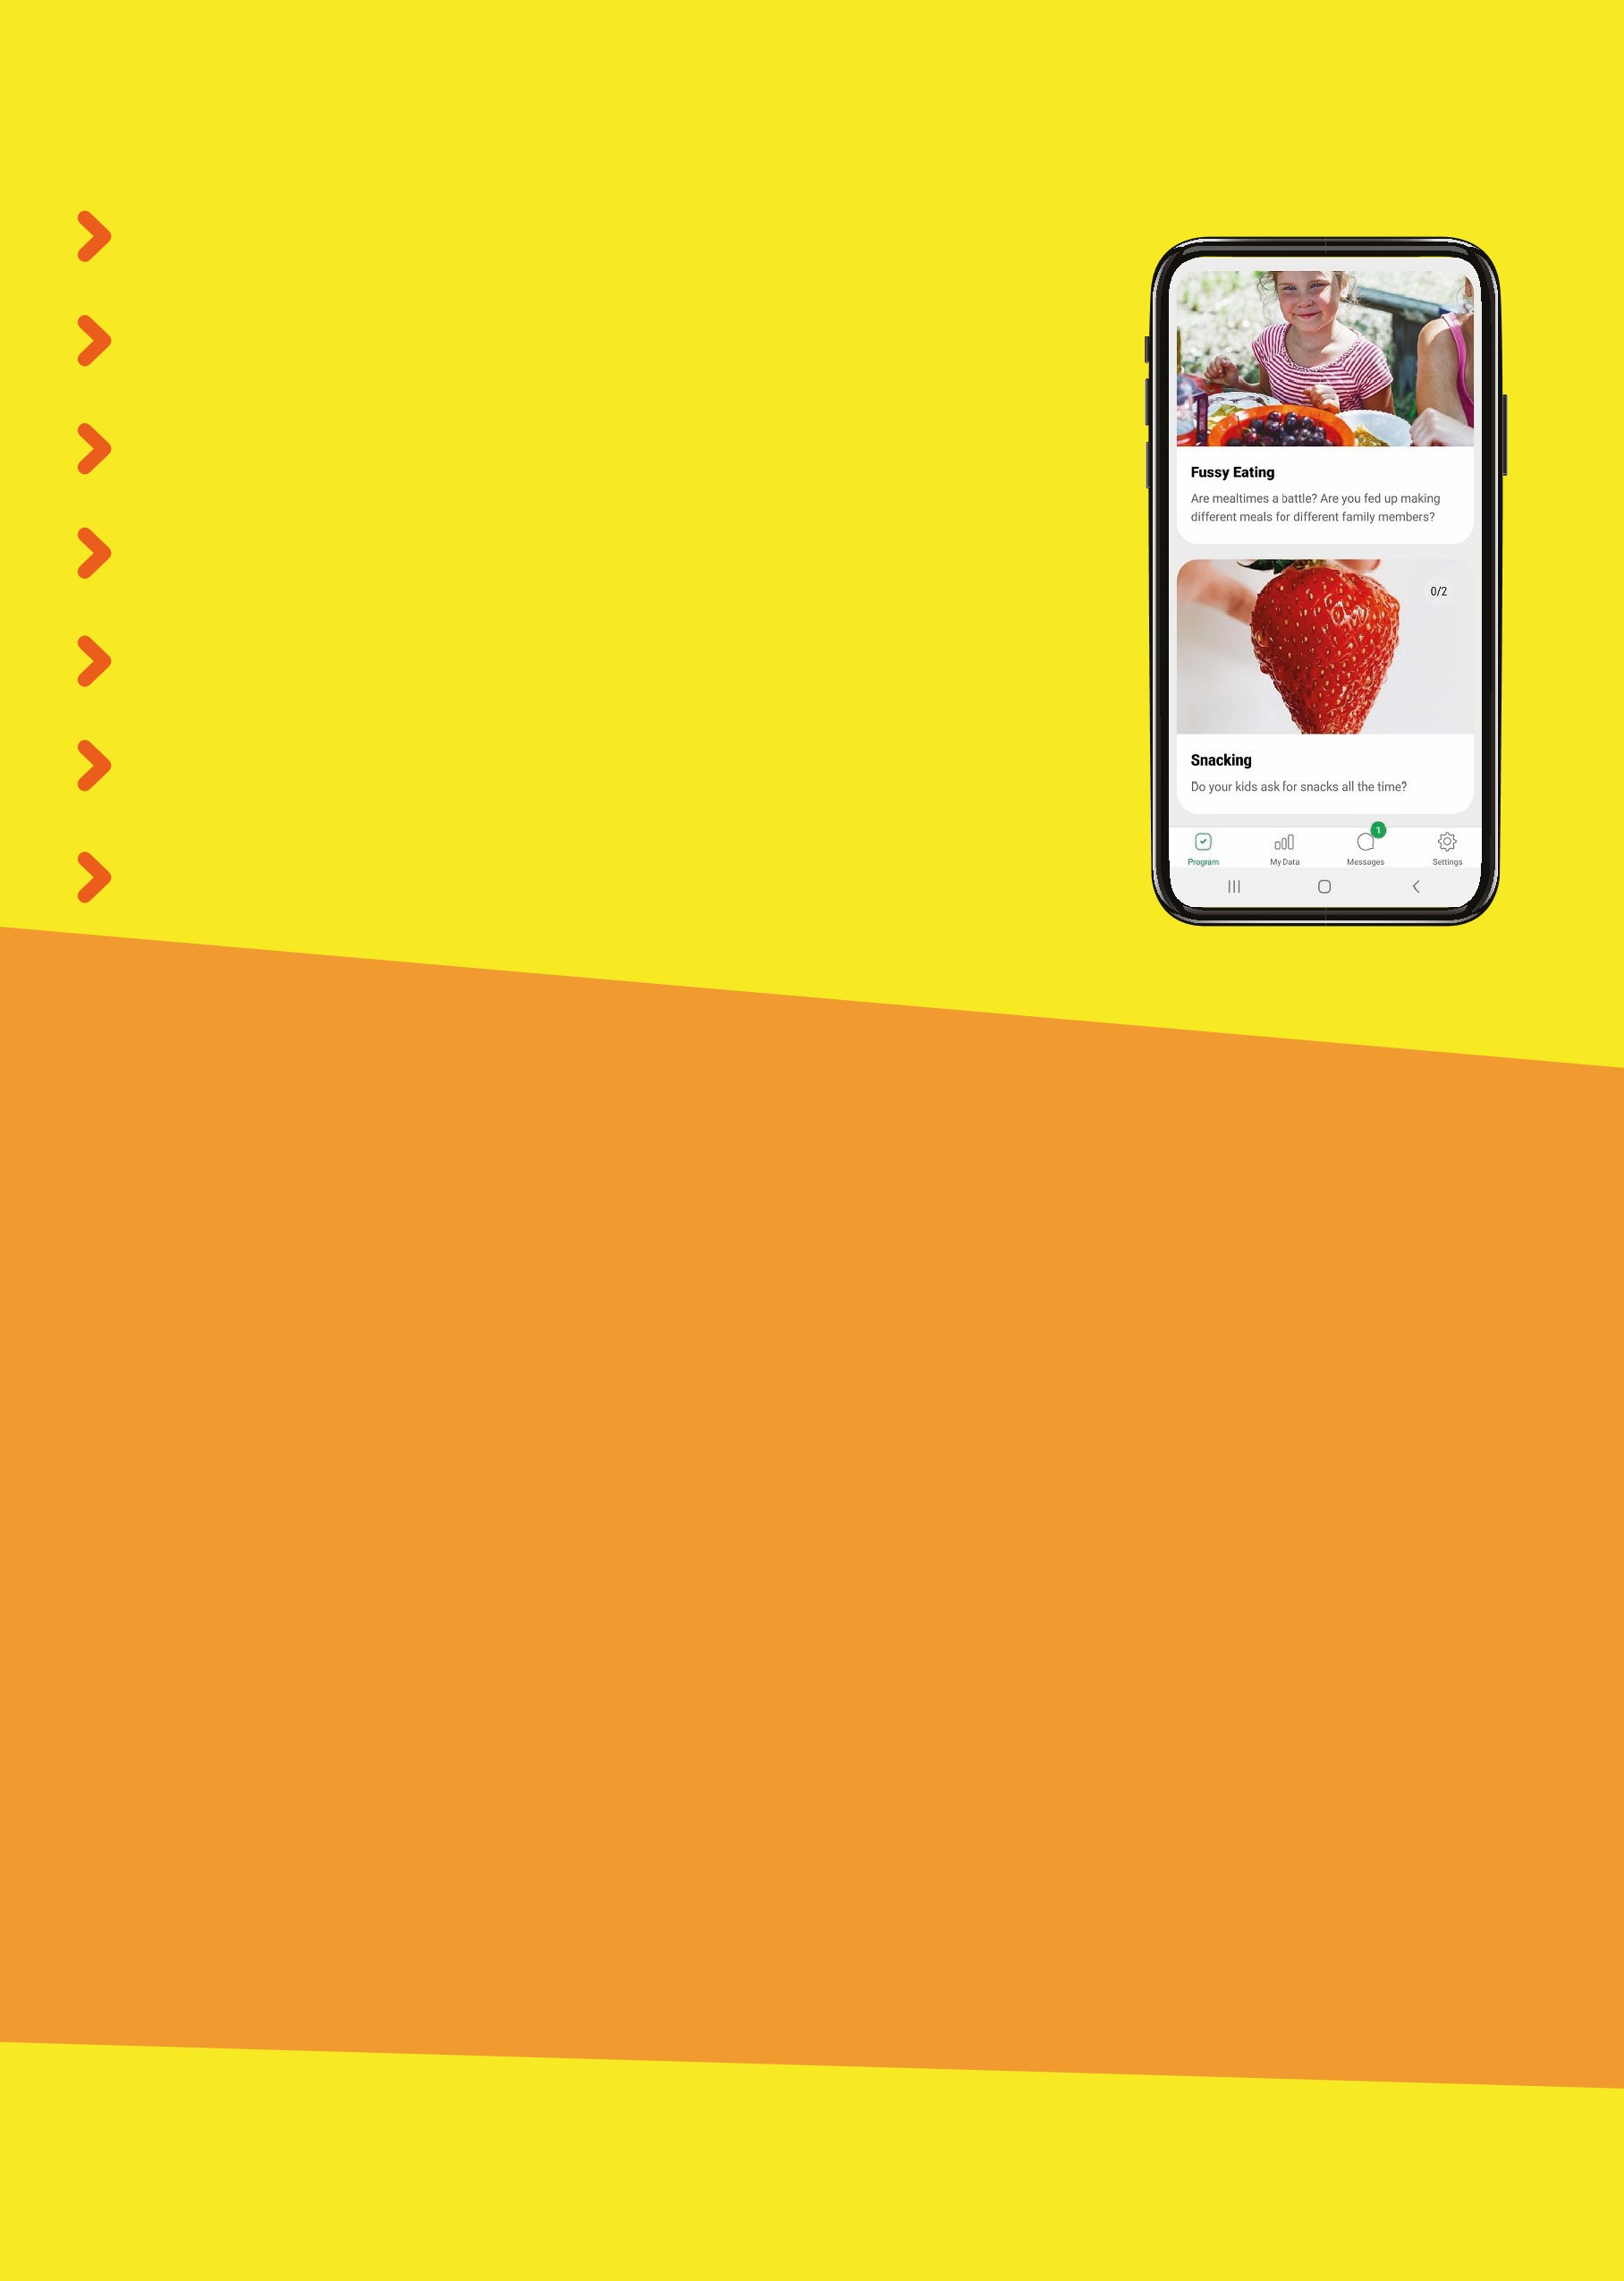
Your coach will support you throughout the 12-week programme. During your sign-up call they will discuss your goals and help to motivate you to get started. You can chat regularly with your coach via instant messaging within the app. They will also call you at the end of the programme to discuss your progress and next steps.
If you are currently being supported by another professional, they can also download the app to support you along your journey.
To find out more call Halton Health Improvement Team on 0300 029 0029 or email HIT@halton.gov.uk

