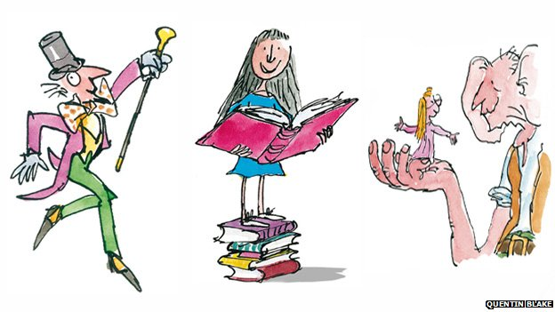

On Friday 13 September 2019, we will be celebrating the worlds, characters and stories of the world's no. 1 storyteller Roald Dahl.
Children are to come to school in their own clothes with a donation of £1.00 for school funds.

Roald Dahl Day

On Friday 13 September 2019, we will be celebrating the worlds, characters and stories of the world's no. 1 storyteller Roald Dahl.
Children are to come to school in their own clothes with a donation of £1.00 for school funds.

